To set up the Moodle API for user creation, you'll need to follow a few steps. Here's a guide to help you get started:

### 1. ****Enable Web Services in Moodle****

* **Log in as Admin**: Log in to your Moodle site as an administrator.
* 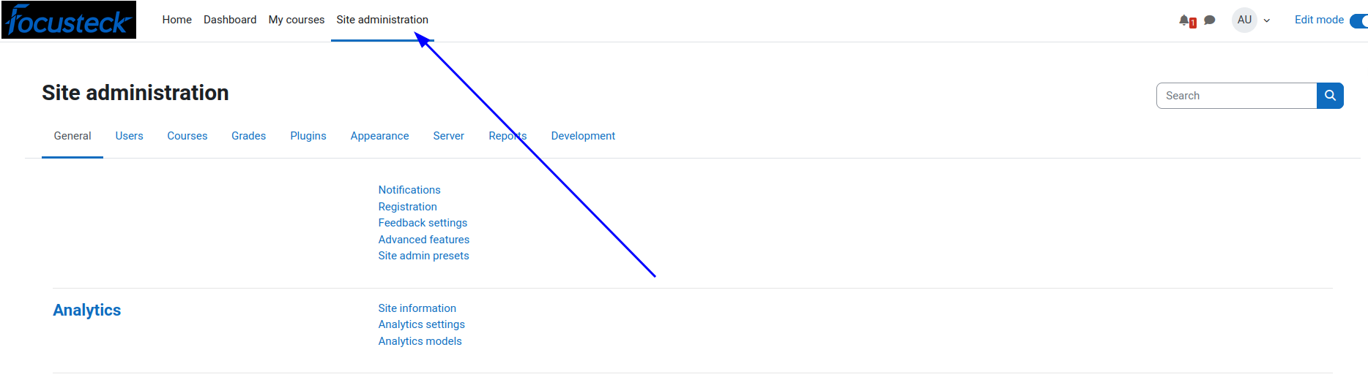
* **Enable Web Services**:
  1. Go to Site administration > Server > WebServices. > Overview
  2. 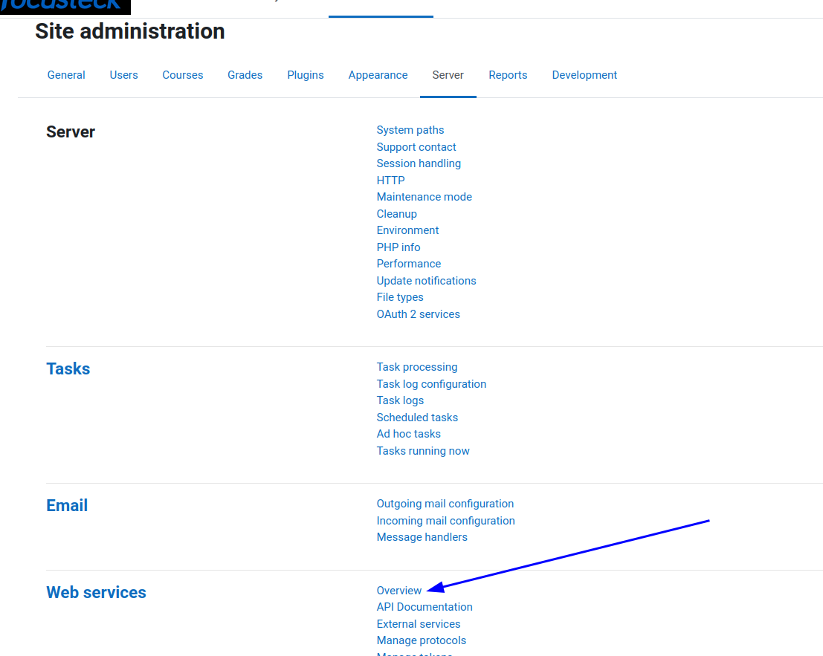
  3. Check Enable web services.
  4. 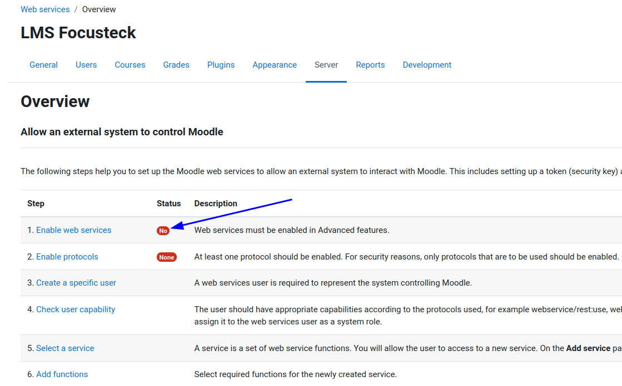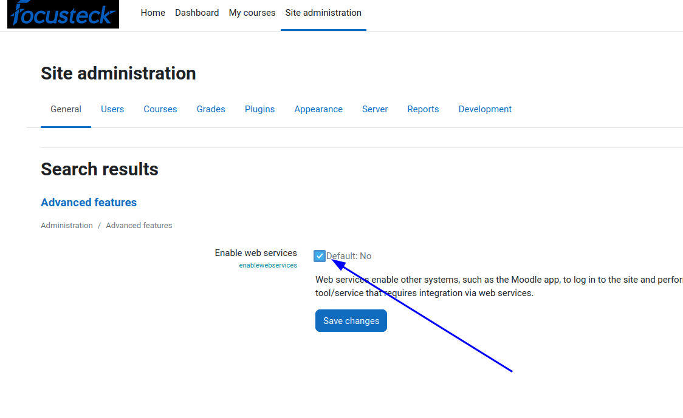
  5. Save the changes.
  6. 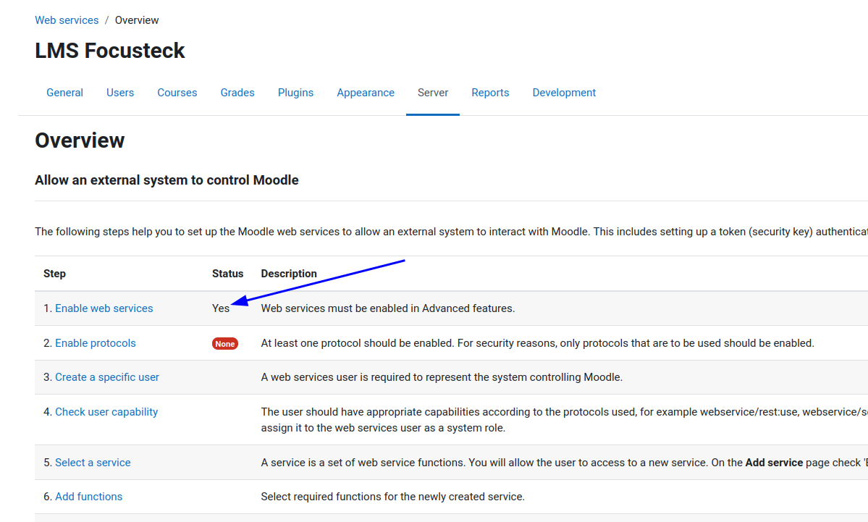

### 2. ****Create a Web Service Role****

* **Create a Role**:
  1. Go to Site administration > Users > Permissions > Define roles.
  2. 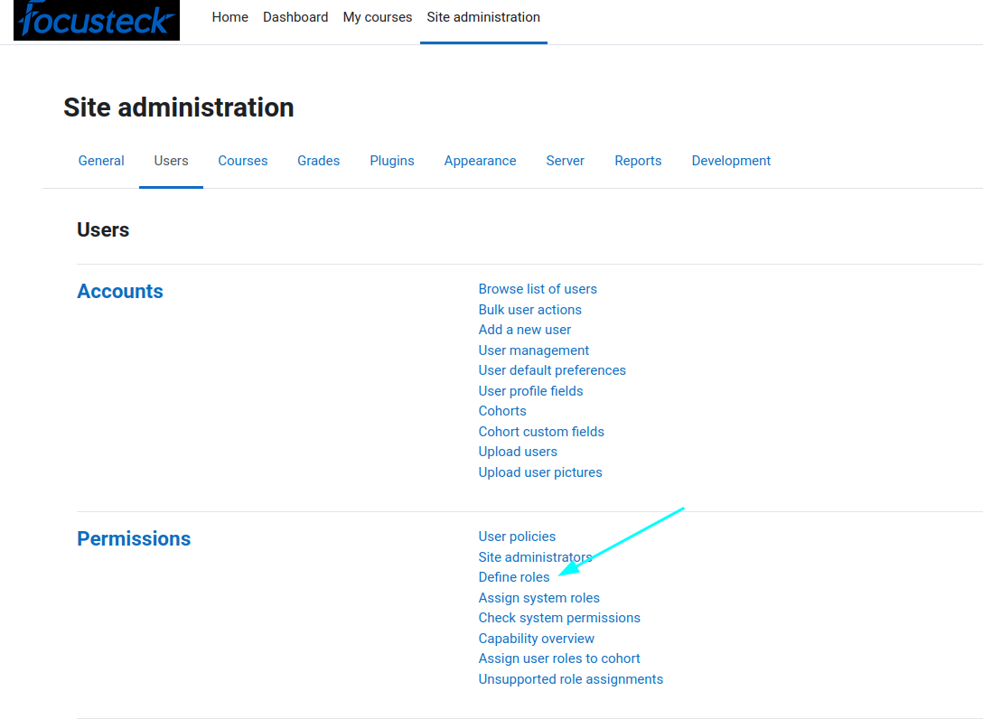
  3. Click on Add a new role.
  4. 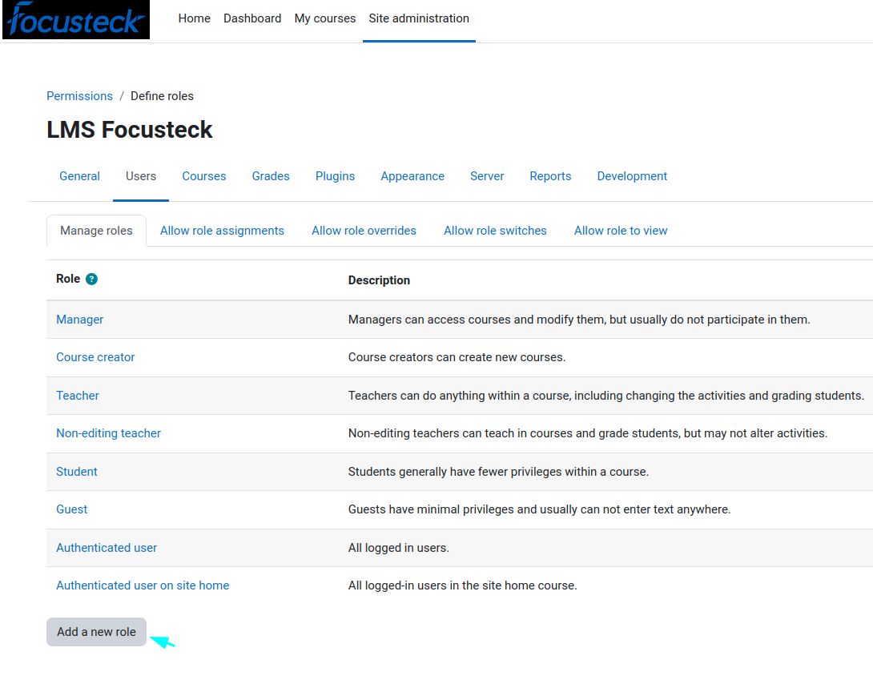
  5. Define a role name, for example, **api-user.**
  6. 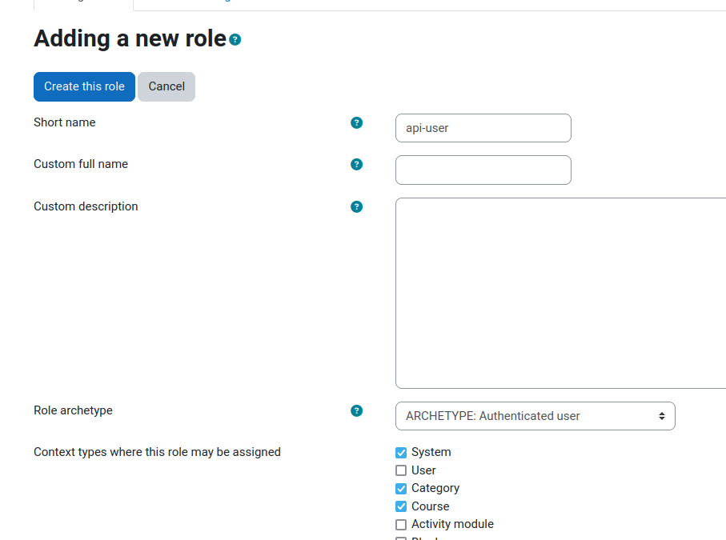
* **Assign Capabilities**:
  1. Search for and enable relevant capabilities like:
     + moodle/webservice:createtoken
     + moodle/user:create
     + moodle/user:update
     + moodle/user:view
     + 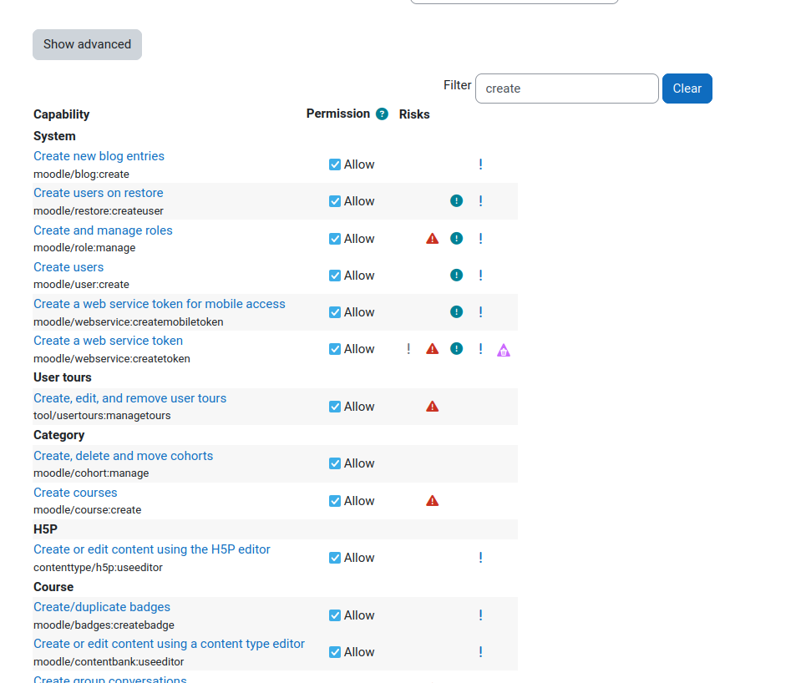
  2. Create this role
  3. 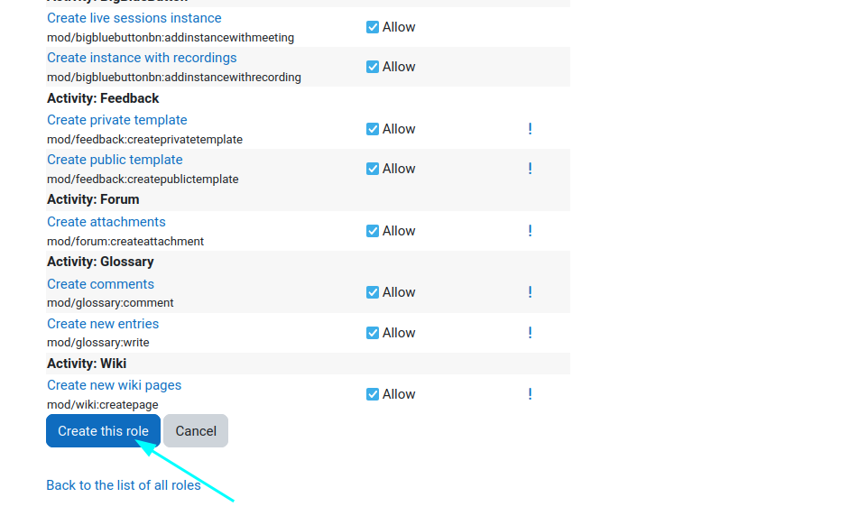

### 3. ****Create a Web Service User****

* **Add a New User**:
  1. Go to Site administration > Users > Accounts > Add a new user.
  2. 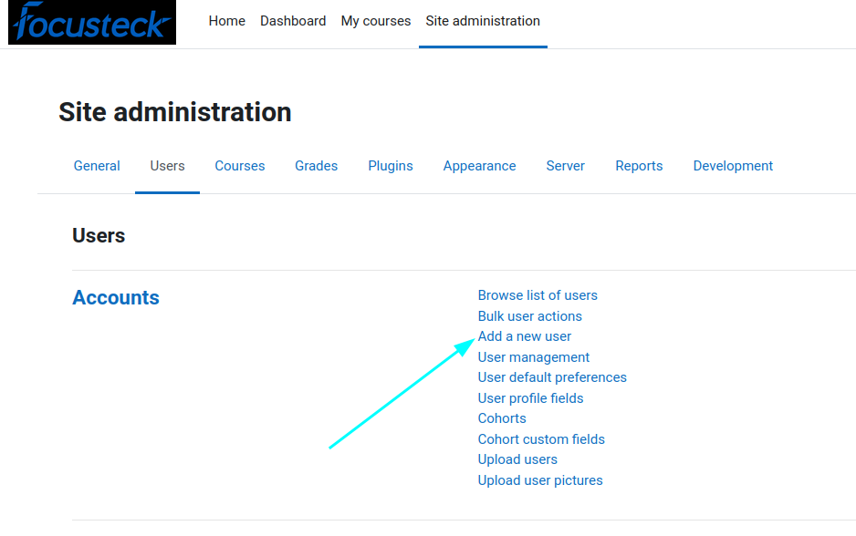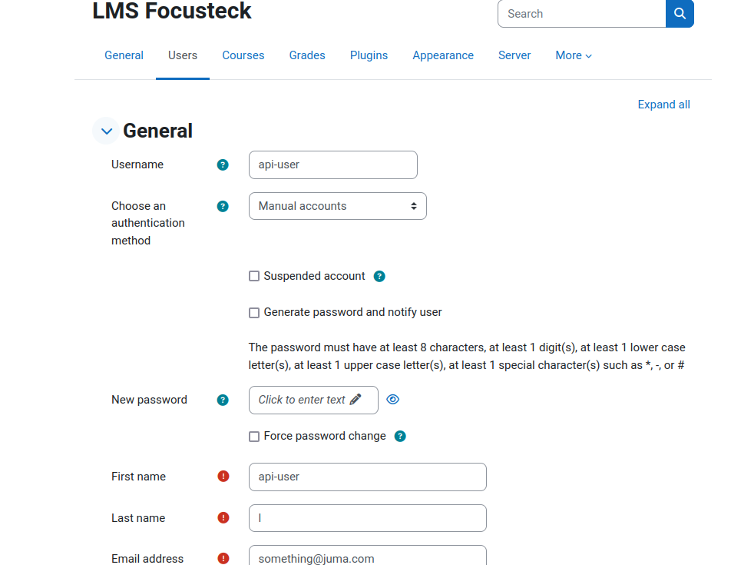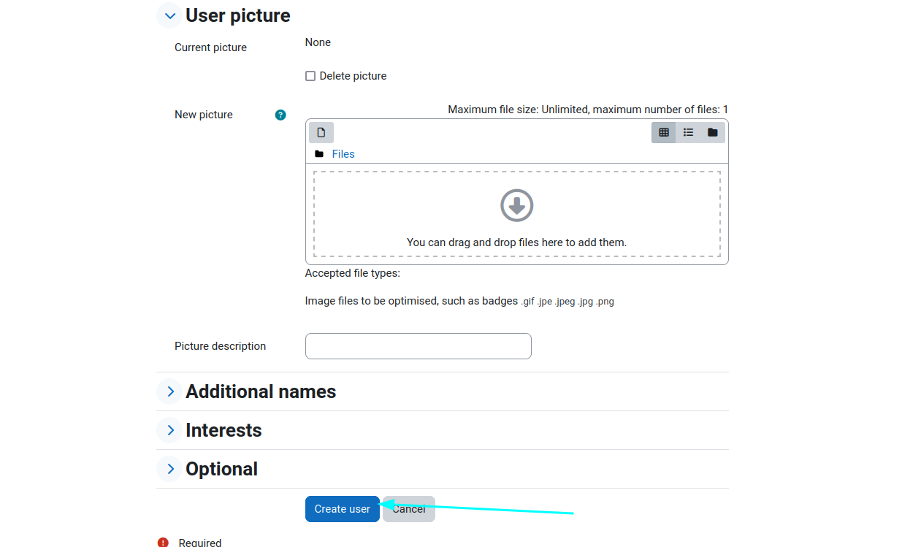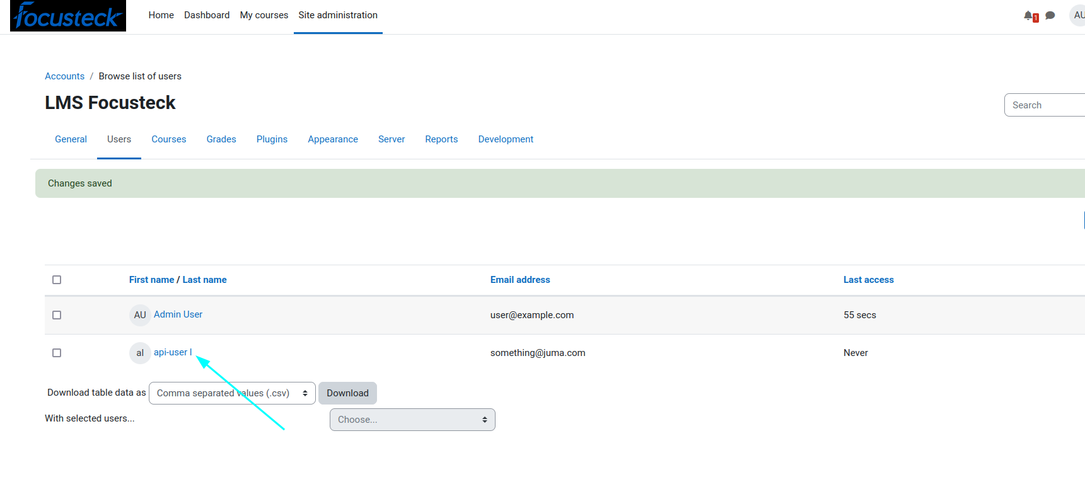
  3. Fill in the required details for the user who will be assigned to handle the web services.
* **Assign the Role to the User**:
  1. Go to Site administration > Users > Permissions > Assign system roles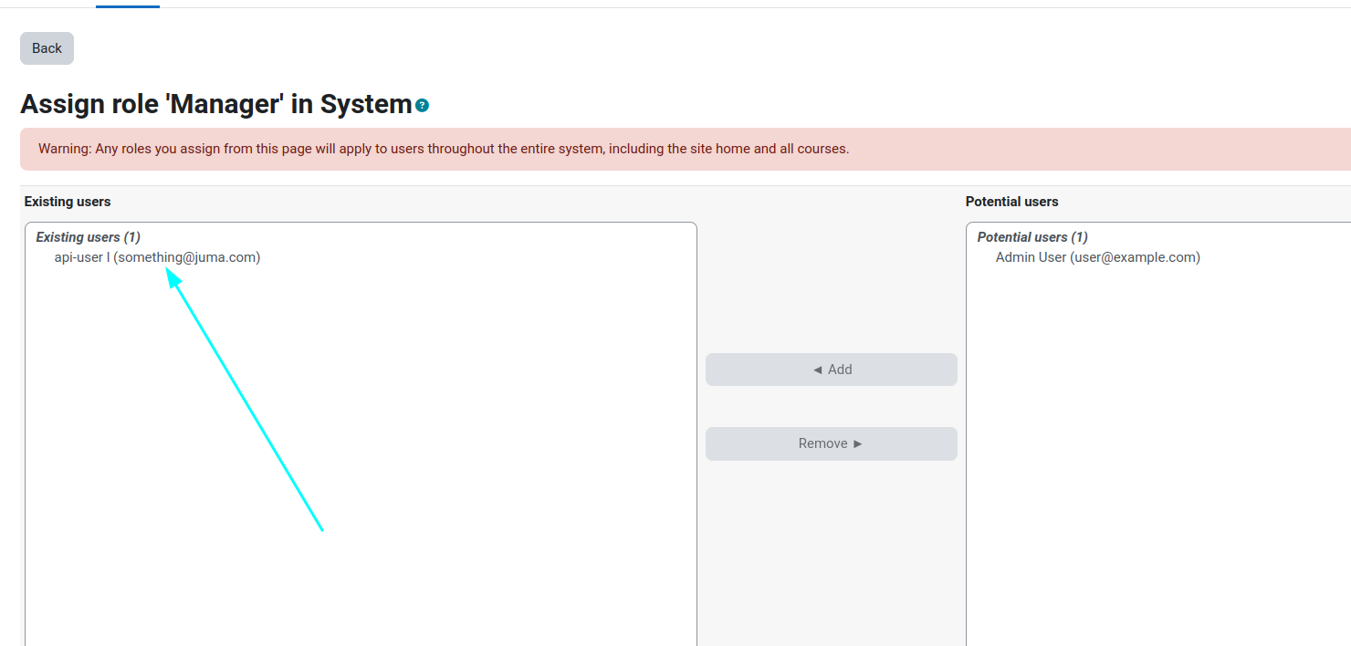.
  2. Assign the **api-user** role to the newly created user.

### 4. ****Enable the REST Protocol****

* **Enable REST**:
  1. Go to Site administration > Server > Web services > Manage protocols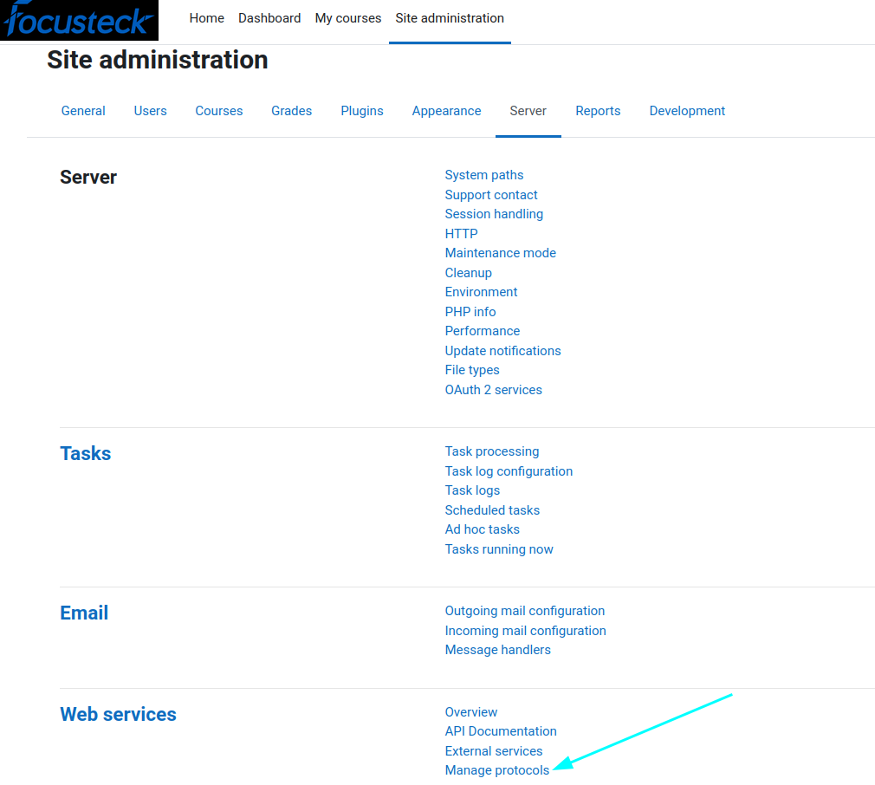.
  2. Enable the REST protocol by clicking on the eye to enable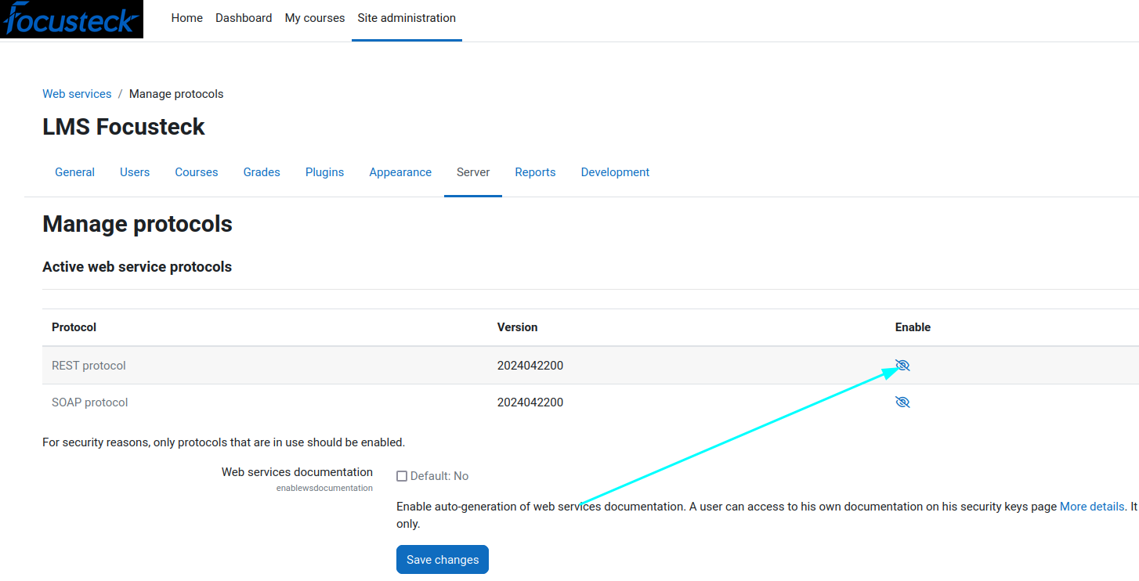 and save changes
  3. 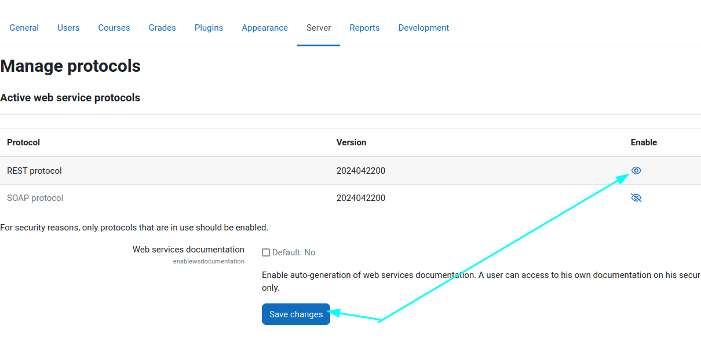

### 5. ****Create a Web Service****

* **Add a New Service**:
  1. Go to Site administration > Server > Web services > External services.
  2. 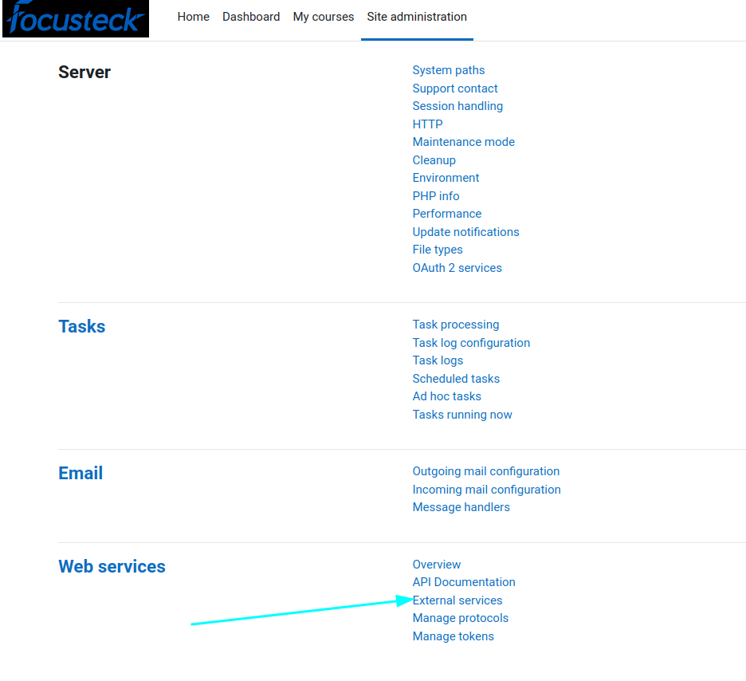
  3. Add a new service and name it, for example, User Creation Service.
  4. Ensure the service is enabled and is selected.
  5. 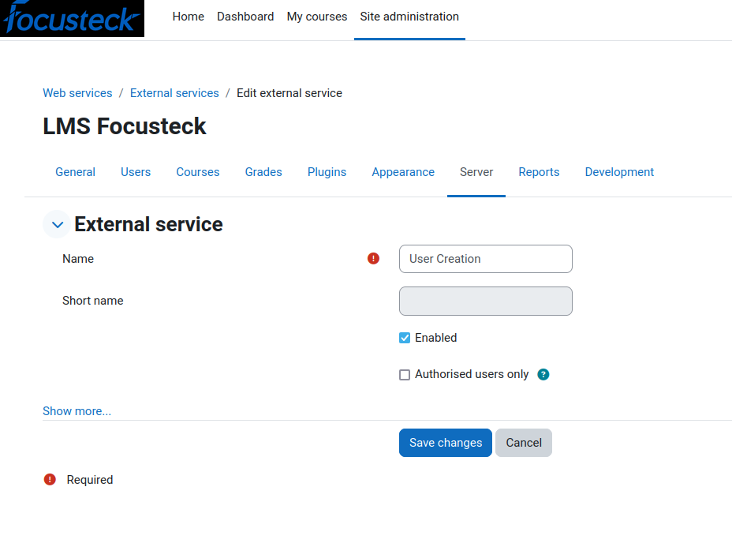
* **Add Functions**:
  1. After creating the service, click on Functions next to the service name.
  2. 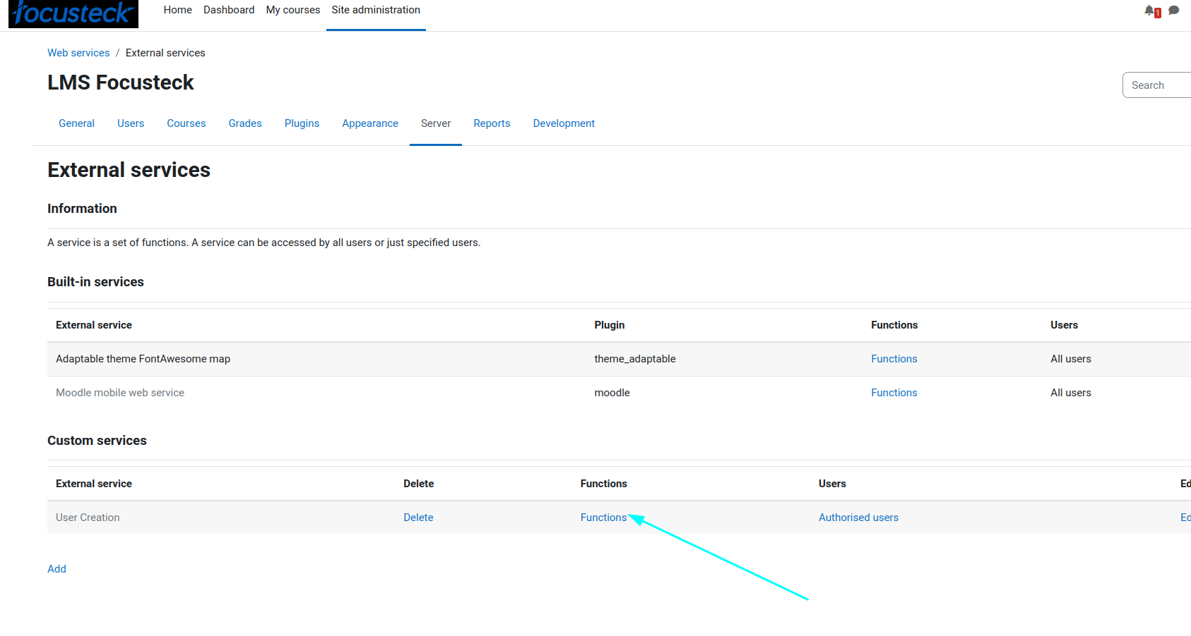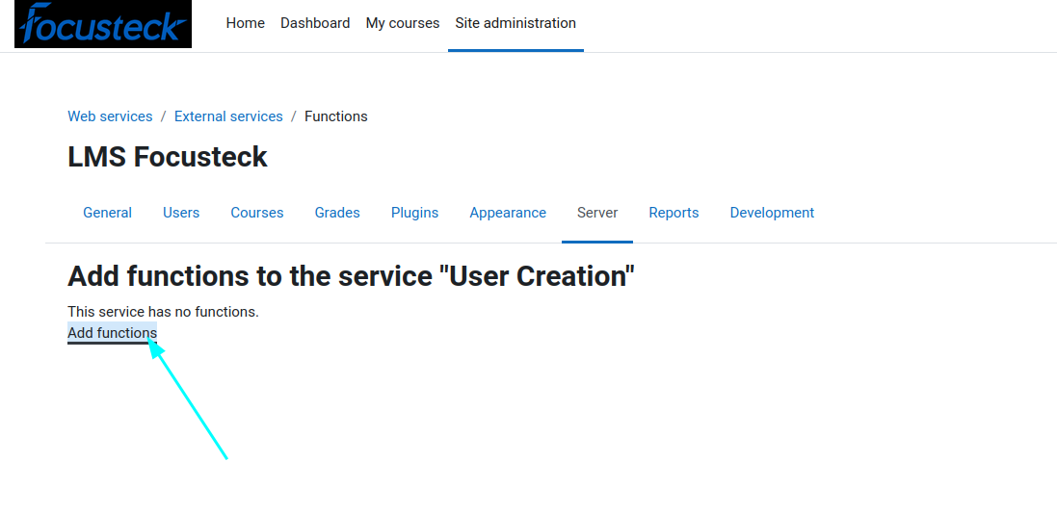
  3. Add the following functions to the service:
     + core_user_create_users (for creating users)
     + 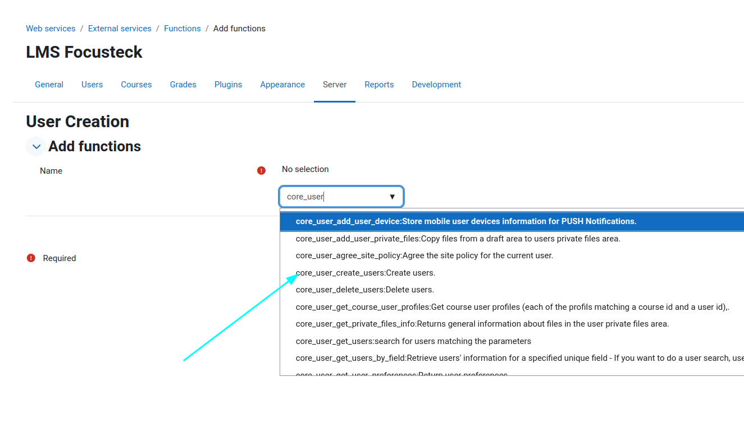
     + core_user_update_users (for updating users)
     + 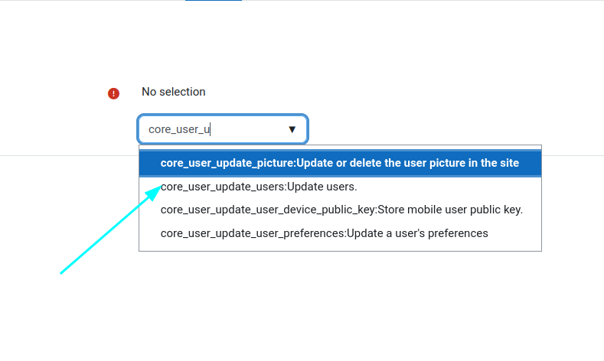
     + core_user_delete_users (for deleting users)
     + 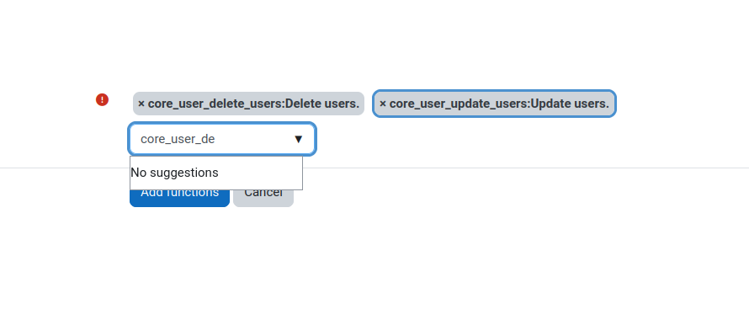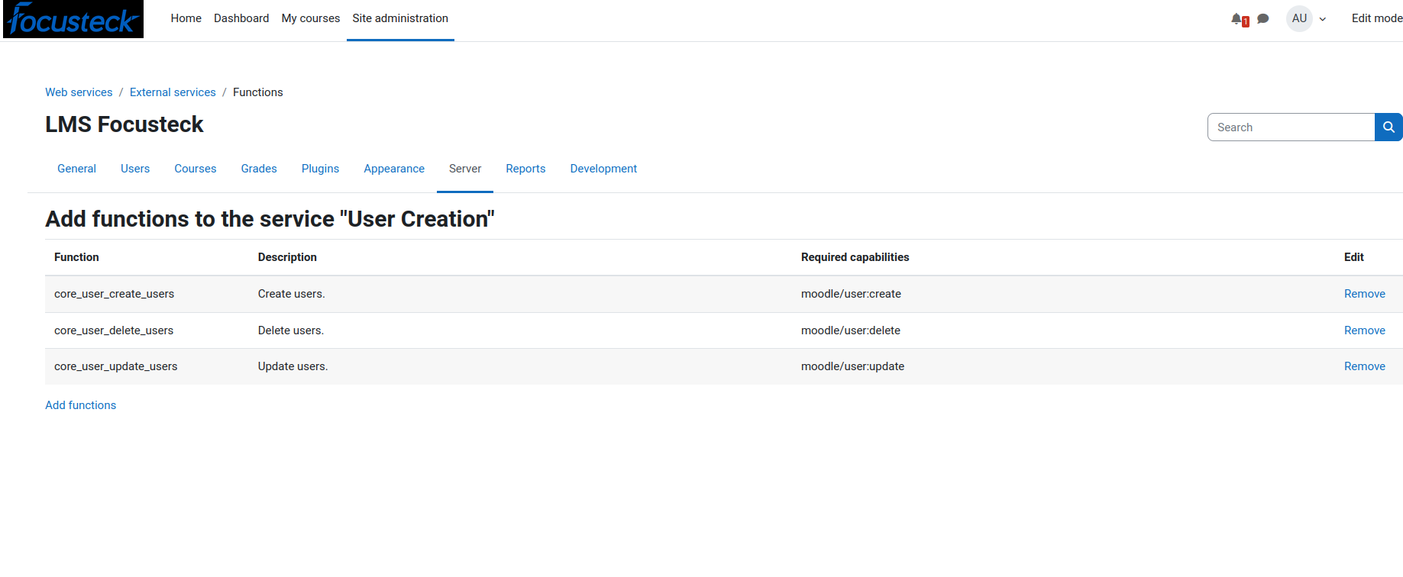

### 6. ****Create a Token for API Access****

* **Generate a Token**:
  1. Go to Site administration > Server > Web services > Manage tokens.
  2. 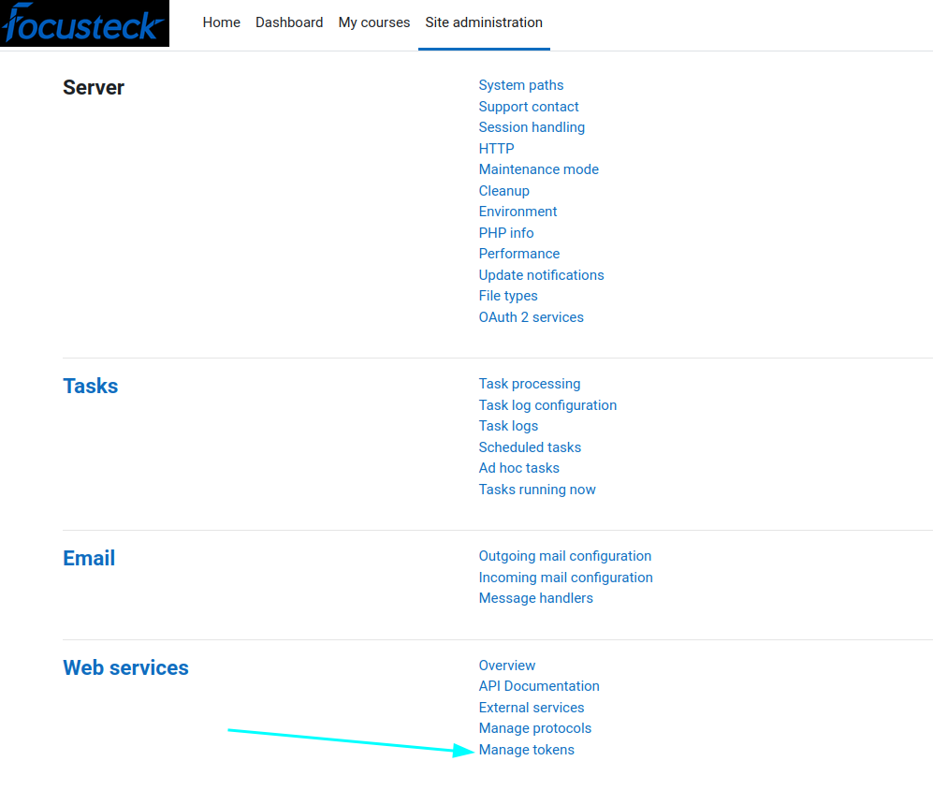
  3. Click Add to generate a new token.
  4. 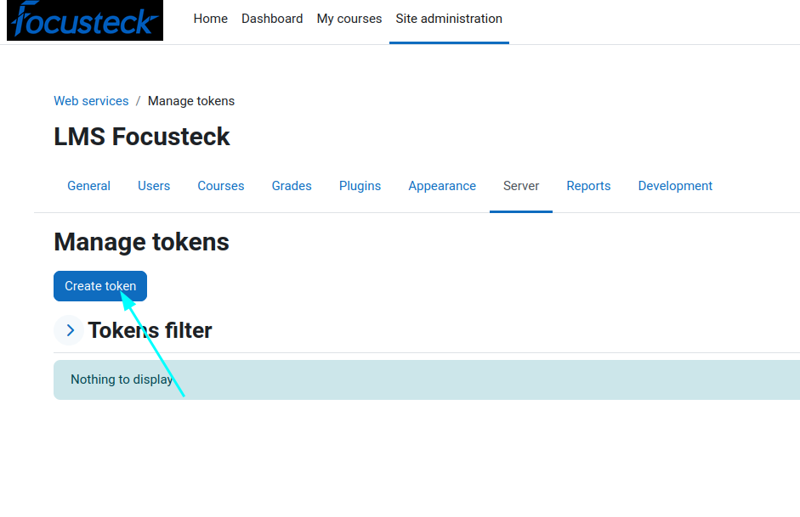
  5. Select the web service user you created earlier and the service (User Creation Service) to link the token to.
  6. 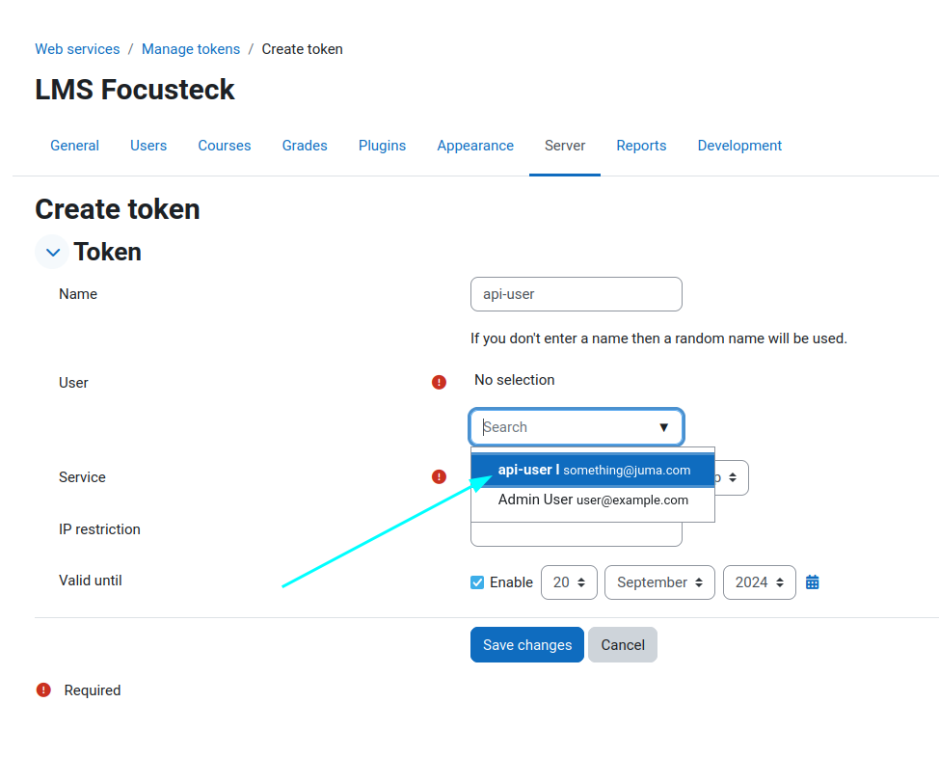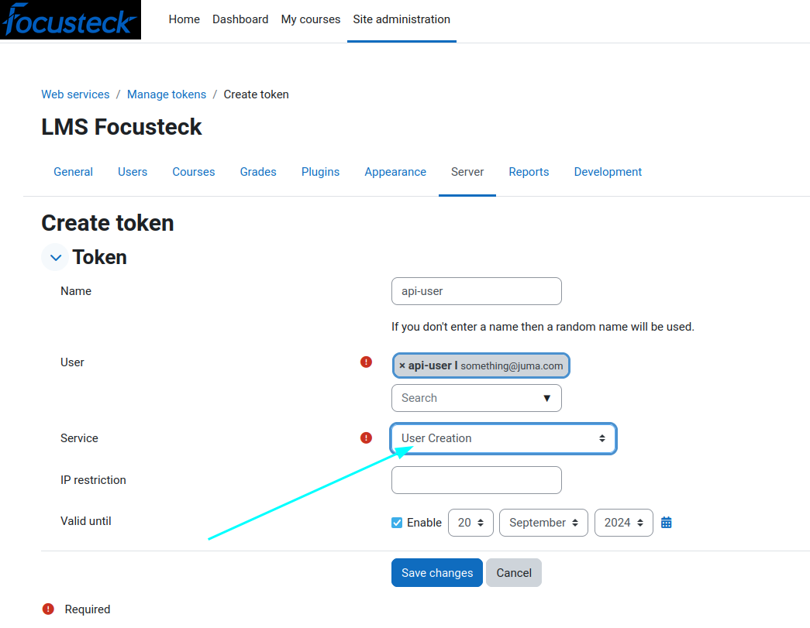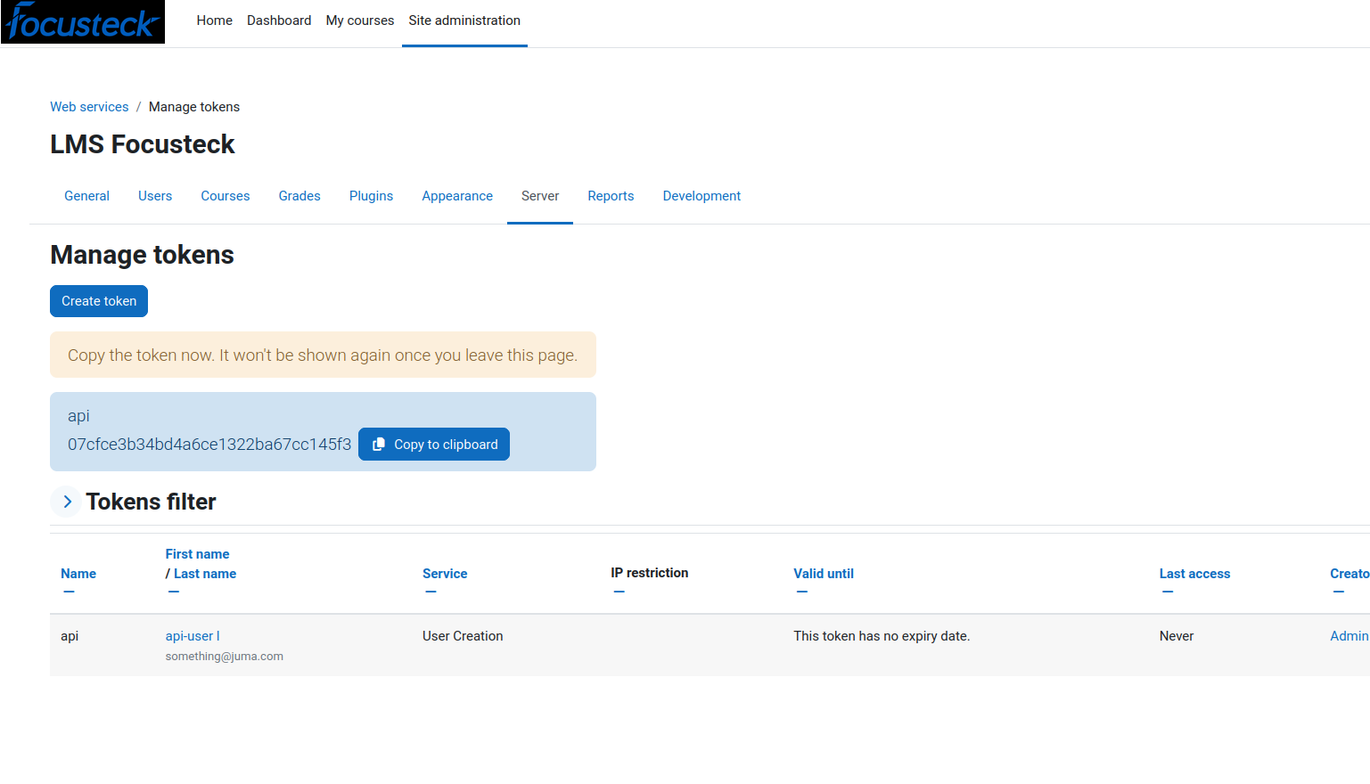
  7. Copy the token as will be used later

### 7. ****Use the Moodle API to Create a User****

* **Make a REST API Call**: To create a user, you need to send a POST request to the Moodle endpoint with the necessary parameters.
* 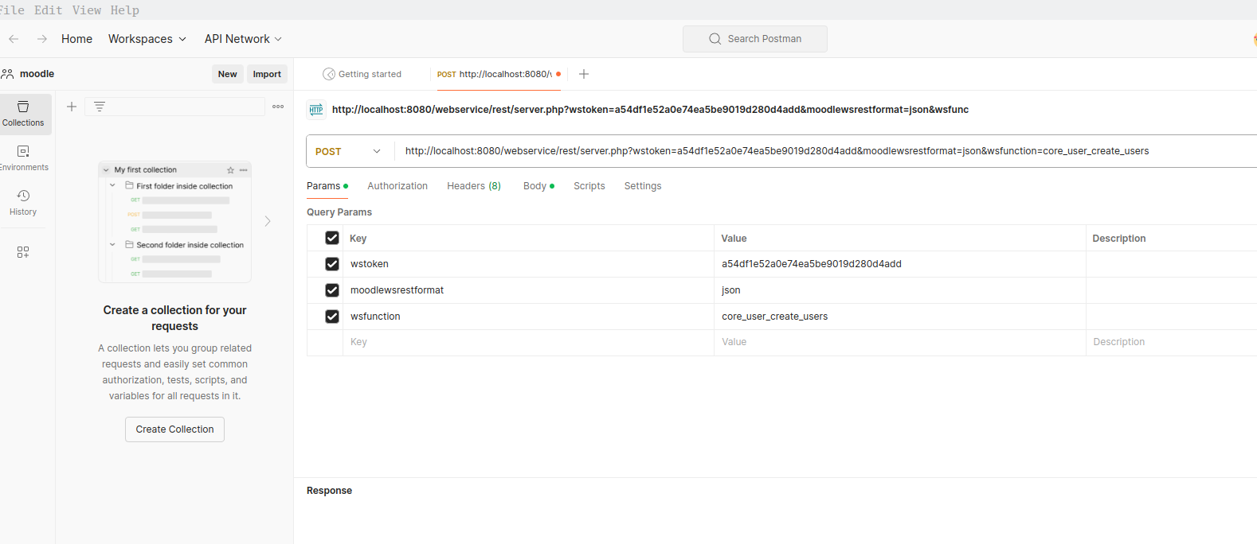I have Postman to test the functiionality

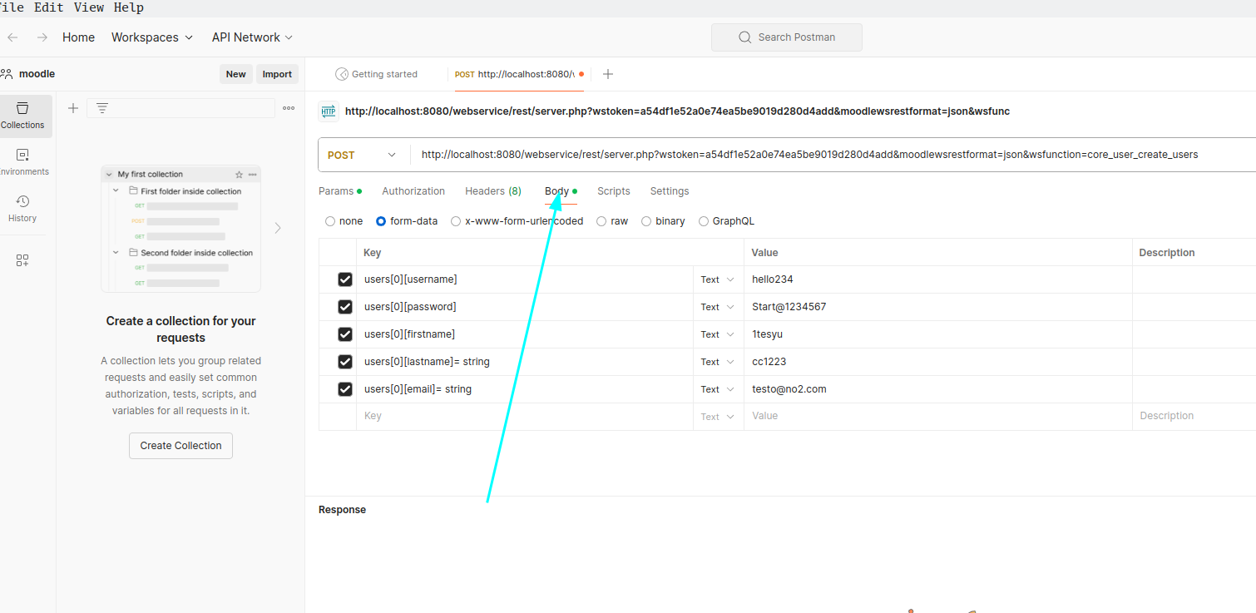

### 8. ****Test the API****

* Send a request to the Moodle server and check the response to ensure that the user creation is successful.

This setup allows you to create users via the Moodle API using a REST call. You can adapt this process for other functions and integrate it into your system as needed.